Low-Level Architecture and Data Models

UNIVERSITY CORRIDOR MEETING ROOM AND WORKSPACE RESERVATION SYSTEM

TEAM: - SYED MEESUM RAZA NAQVI (24100183)

Student ID | Name
24100183 | Syed meesum raza naqvi

Table of Contents

1. Introduction 3
2. System Architecture 4
2.1 Architecture Diagram—As it is in the prototype code 4
2.2 Architecture Diagram—As it should-be 4
3. Data Models 5
4. Tools and Technologies 6
5. Who Did What? 7
6. Review checklist 7

Introduction

Overview:

The Workspace Reservation System is a web app designed to make it easier for people to book tables/workspaces in university department rooms. It’s built using modern technology of MERN stack (MongoDB, Express.js, React.js, Node.js), which helps it run smoothly and look simple to use. The system is made to help Teaching Assistants (TAs) and Coordinators manage workspaces in a way that is both organized and hassle-free.

Objectives:

- Make Booking Simple: The system makes it easy to find and reserve workspaces by showing what’s available and letting users search by date, time, and room number.
- Prevent Booking Issues: It ensures no two people can book the same table at the same time, which keeps things fair and avoids confusion.
- Clean Up Old Bookings: Past bookings are automatically deleted, which helps keep the system clean and easy to navigate.
- Support Different User Roles: There are separate features for TAs and Coordinators, which make sure everyone has the tools they need for their specific tasks.

Potential Users:

- Teaching Assistants (TAs): TAs can reserve up to two tables at a time, check their own bookings, and use FAQs for help when needed.
- Coordinators (Admins): Coordinators can book as many tables as they want, manage everyone’s reservations, create FAQs, and add or remove users.

This system is designed to save time and make managing shared spaces easier, which helps both users and administrators focus on their work without worrying about booking problems.

System Architecture

Architecture Diagram—As it is in the prototype code

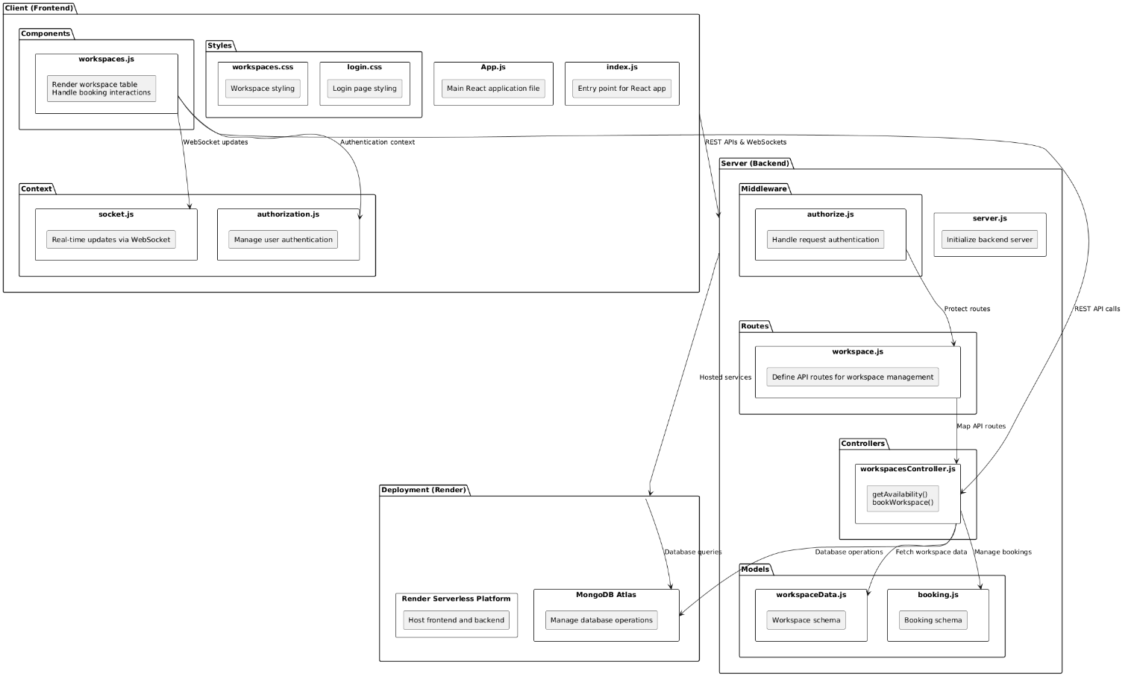

Architecture Diagram—As it should-be

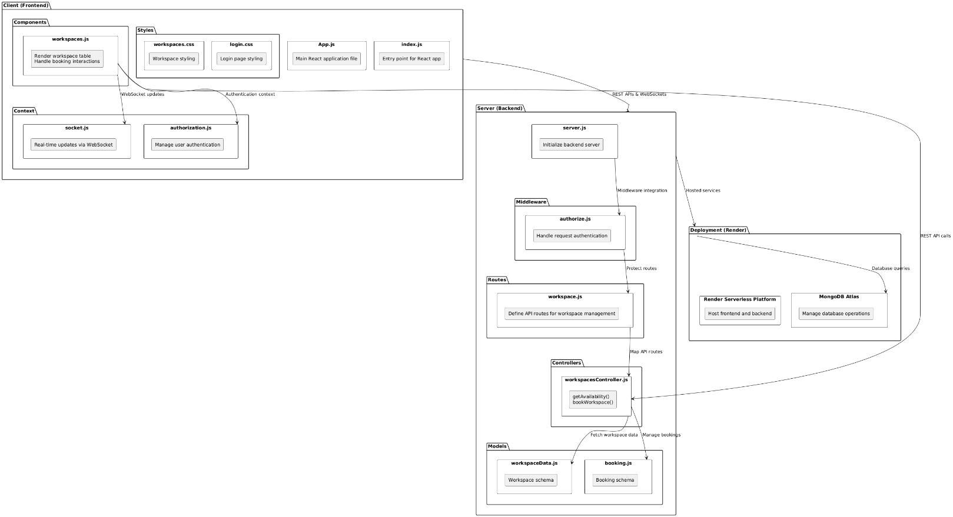

The updated architecture improves upon the initial design by focusing on maintainability, reusability, extensibility, and separation of concerns, as outlined below:

1. Maintainability
The updated architecture clearly separates concerns between the frontend, backend, and database. Each module, such as workspacesController.js or authorization.js, handles a specific responsibility, reducing complexity. For instance, the authorization.js file is isolated to manage user authentication, making debugging and updates simpler. Similarly, by hosting frontend and backend separately on Render, any changes can be made independently without affecting the overall system.

2. Reusability
Core logic in workspacesController.js and schemas like workspaceData.js and booking.js is reusable across different use cases. For example, the bookWorkspace() function in the controller can serve both the workspace reservation module and potential future features, such as automated booking scheduling or bulk booking functionality.

3. Extensibility

The architecture allows for future feature expansion without major structural changes. For instance:
- Adding new API routes for advanced workspace analytics or reporting would only require extending the workspace.js routes and corresponding controllers.
- Real-time updates through WebSockets (socket.js) can be further enhanced for features like live availability monitoring or notifications.

4. Separation of Concerns
The layered architecture ensures that each module has a clearly defined role:
- Frontend: Handles user interactions and rendering via components like workspaces.js.
- Backend: Manages API routes (workspace.js), business logic (workspacesController.js), and database interactions (models like workspaceData.js).
- Middleware: Focuses on security and request validation.
- Database: Centralized in MongoDB Atlas to store and manage workspace and booking data efficiently.
By adhering to the principles of separation of concerns, updates, and maintenance become faster and more reliable. For example, updating the booking.js schema for additional fields will not require changes to the frontend or other unrelated backend modules.

Summary
The updated architecture aligns with modern design principles, creating a modular, scalable, and easy-to-maintain system. It ensures clear boundaries between components, promotes code reuse, and simplifies the addition of new features, which is vital for both the current functionality and future scalability of the application.

Data Models

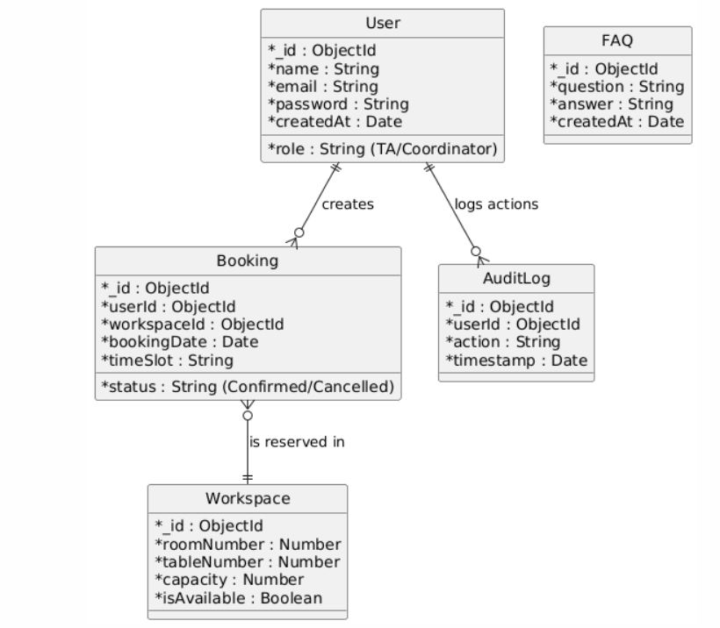

Tools and Technologies

- Front-End: React.js (v18.0)

- Back-End: Node.js (v16), Express (v4.x)

- Database: MongoDB Atlas

- Notification System: NodeMailer for email notifications

- Testing: Selenium for UI testing

- Development IDE: Visual Studio Code

- Deployment Platform: Render for hosting

- Version Control: Git (GitHub repository)

Who Did What?

Name of the Team Member | Tasks done
Syed Meesum Raza Naqvi | Introduction, System architecture, Data Models, Tools and technologies

Review checklist

Before submission of this deliverable, the team must perform an internal review. Each team member will review one or more sections of the deliverable.

Section Title | Reviewer Name(s)
Introduction | Syed Meesum Raza Naqvi
System Architecture | Syed Meesum Raza Naqvi
Data Models | Syed Meesum Raza Naqvi
Tools and Technologies | Syed Meesum Raza Naqvi

